Permit specific pipeline to the developer in Jenkins

* With this methodology we can give access to a specific pipeline to the developer and keeping other pipelines invisible
* This strategy is useful when a developer wants to view logs of the failed build

Steps

* We need to install this plugin in Jenkins - 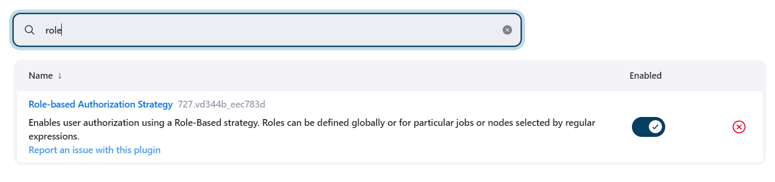
* With this plugin we can manage permissions for the users
* After installing this plugin we can see new tab in security section know as mange and assign role

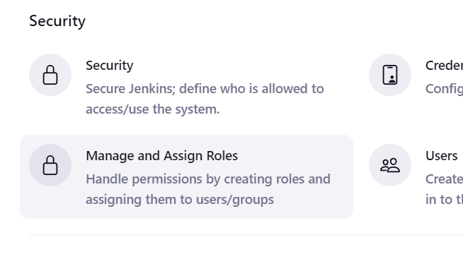

* Get in to manage and assign roles

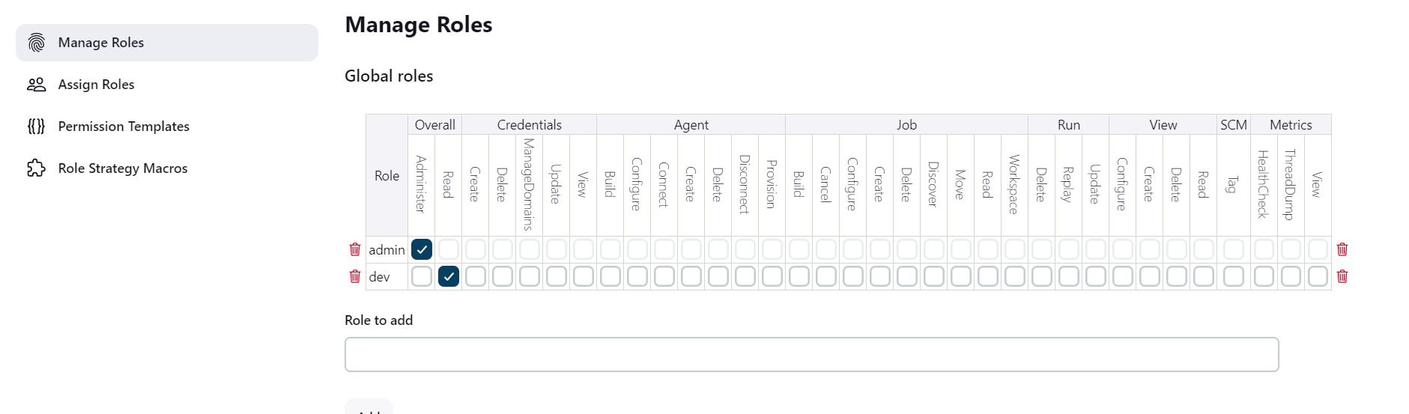

* Now in manage roles go into global roles and add a stage for developer in this img stage is dev
* After adding dev give overall read permission

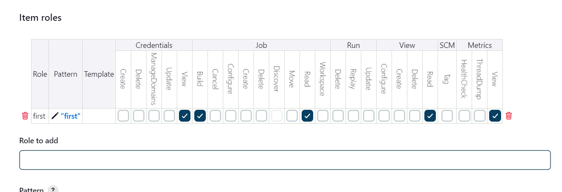

* Now in the item role add the pipeline name you want to give access to and add specific permission to it

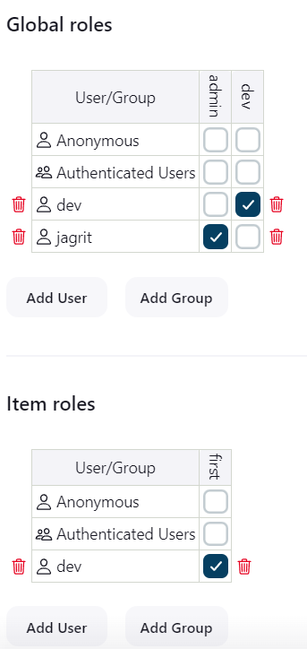

* After that go to assign roles and there add the user to both global as well as item roles and assign permission
* Now login from developer account
* 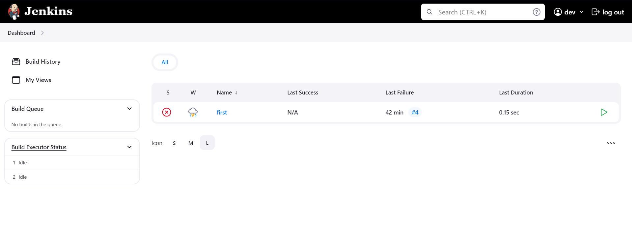
* As we can see there is only one pipeline showing which we have given permission of